**High level Design:**

**1 Structural diagram:**

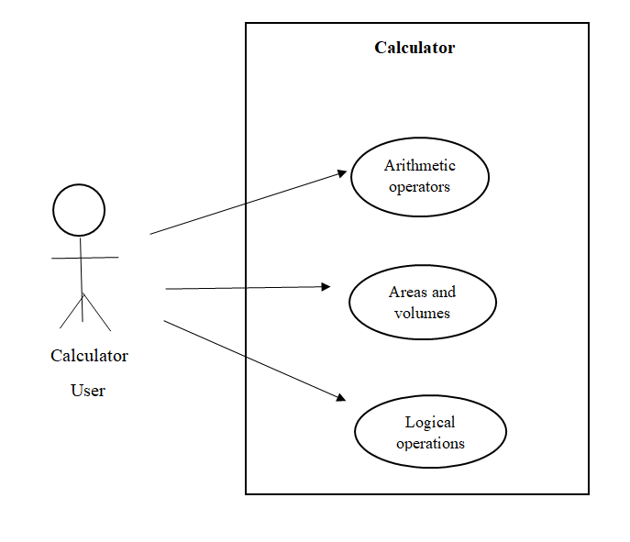

**2 Behavioural diagram:**

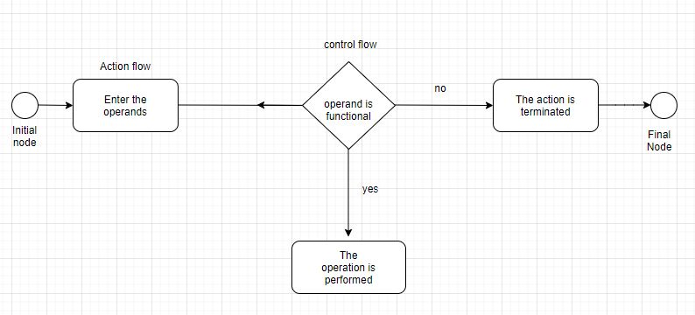

**3. Low Level Behavioural Diagram**

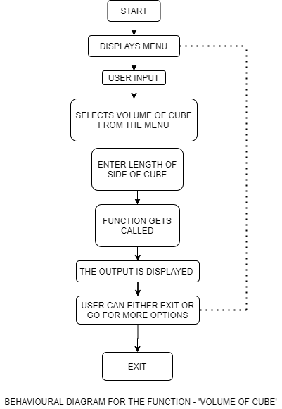

**4 low level structural design**

